**PIZZA SALES SQL QUERIES**

**A. KPI’s**

**1. Total revenue:**

SELECT SUM(total_price) AS total_revenue FROM pizza_sales;

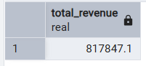

**2.Average Order Value**

SELECT SUM(total_price)/count(distinct order_id)as avg_order_value FROM pizza_sales;

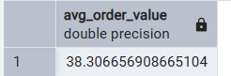

**3. Total Pizzas Sold**

SELECT SUM(quantity) AS total_pizzas FROM pizza_sales;

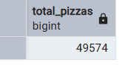

**4. Total Orders**

SELECT COUNT(distinct order_id)as total_orders FROM pizza_sales;

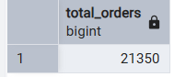

**5. Average Pizzas Per Order**

select cast(cast(sum(quantity) as decimal(10,2))/cast(count(distinct order_id) as decimal(10,2)) as decimal(10,2)) as avg_pizza_per_order from pizza_sales;

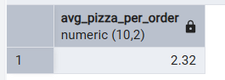

**B.**

**1.Daily Trend for Total Orders**

select To_char( order_date, 'day') as weekdays , count(distinct order_id) from pizza_sales

group by To_char( order_date, 'day');

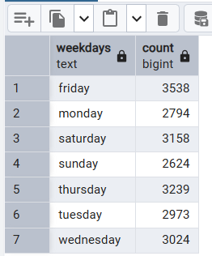

2. **Monthly Trend for Orders**

select To_char( order_date, 'month') as weekdays , count(distinct order_id) from pizza_sales

group by To_char( order_date, 'month');

. 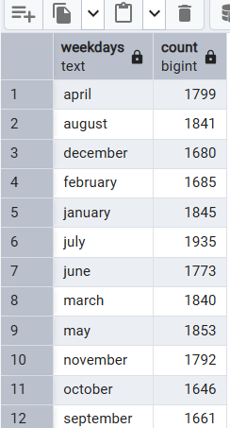

3. **% of Sales by Pizza Category**

select

cast(sum(total_price) as decimal (10,2)),

pizza_category ,

cast(sum(total_price) *100 / (select sum(total_price) from pizza_sales) as decimal(10,2)) as percentage

from pizza_sales

group by pizza_category;

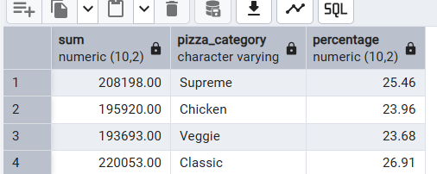

4.

**% of Sales by Pizza Size**

select

cast(sum(total_price) as decimal (10,2)) as revenue,

pizza_size ,

cast(sum(total_price) *100 / (select sum(total_price) from pizza_sales) as decimal(10,2)) as percentage

from pizza_sales

group by pizza_size;

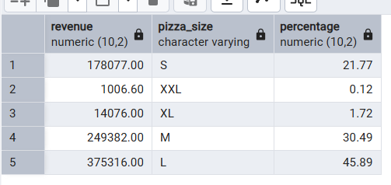

5. **Total Pizzas Sold by Pizza Category**

select

sum(quantity) as total_pizza_sold ,

pizza_category

from pizza_sales

group by pizza_category

order by total_pizza_sold;

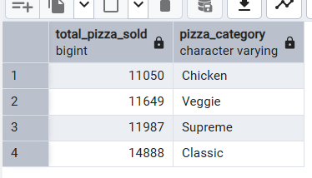

6. **Top 5 pizza by revenue**

select pizza_name,sum(total_price) as revenue from pizza_sales

group by pizza_name

order by sum(total_price) desc

limit 5;

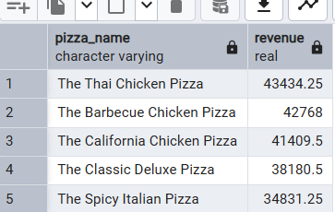

7. **Bottom 5 pizza by revenue**

select pizza_name,sum(total_price) as revenue from pizza_sales

group by pizza_name

order by sum(total_price)

limit 5;

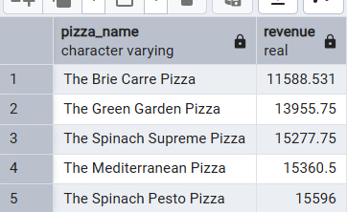

8. **Top 5 pizza by Quantity.**

select pizza_name, sum(quantity) as Quantity from pizza_sales

group by pizza_name

order by sum((quantity)) desc

limit 5;

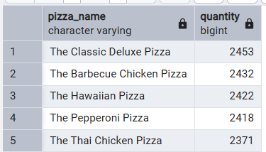

**9. Bottom 5 pizza by Quantity.**

select pizza_name, sum(quantity) as quantity from pizza_sales

group by pizza_name

order by sum((quantity))

limit 5;

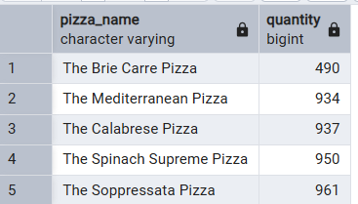

**10. Top 5 pizza by total_order.**

select pizza_name, count(distinct order_id) as total_order from pizza_sales

group by pizza_name

order by count(distinct order_id)desc

limit 5;

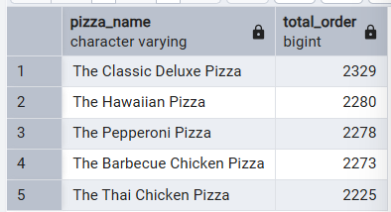

**11. Bottom 5 pizza by total_order.**

select pizza_name, count(distinct order_id) as total_order from pizza_sales

group by pizza_name

order by count(distinct order_id)

limit 5;

